1. Installing Qt 5.15.2 on Ubuntu 20.04

- Deployment Steps on Ubuntu 20.04 Host Environment:
First, extract the firefly_arm64_qt5.15.2_20.04.tgz archive:

```shell
$ sudo apt install -y crossbuild-essential-arm64
$ mkdir -p /opt
$ cd firefly_arm64_qt5.15.2_20.04
$ sudo cp -rfd firefly_qt5.15.2_arm64_20.04 /opt/
$ sudo cp -rfd sysroot /opt/
$ sudo cp host/host_qtEnv.sh /etc/profile.d/
$ reboot

3. Configuring the Cross-Compilation Environment in Qt Creator:
Open QT Creator and navigate to Tools → External → Configure
- Configure Qt Versions:
Click the "Add" button on the right and select qmake from the Qt configuration location.
qmake: /opt/firefly-qt5.15.2_arm64_20.04/host/bin/qmake

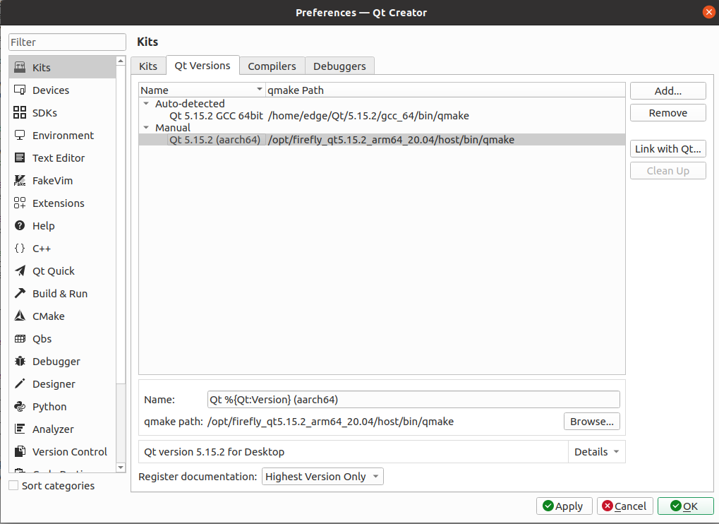

- Configure Compilers
Click the "Add" button on the right to add the locations of the gcc and g++ cross-compilers.
If crossbuild-essential-arm64 is installed on the host machine, the compilers will be located in the /usr/bin/ path.
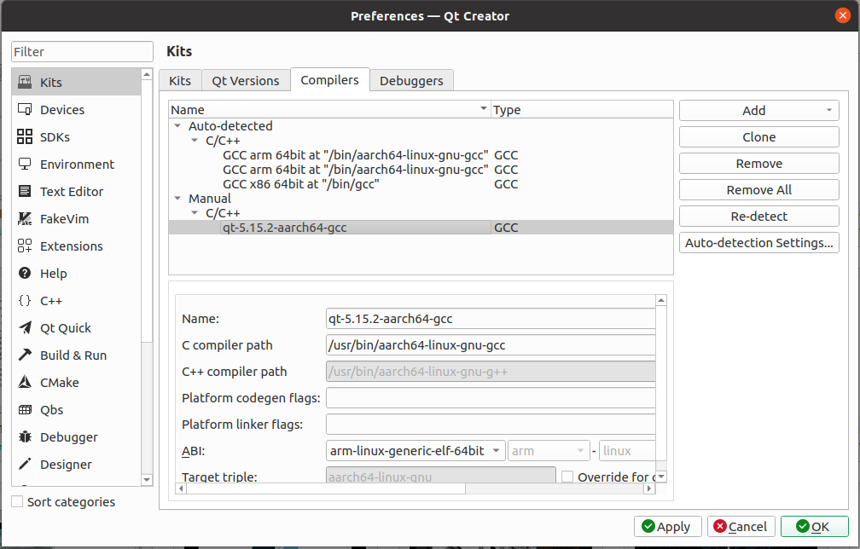

- Configure Kits
Add the previously configured settings into the Kits.
If the target platform is Ubuntu, add the path to the sysroot.

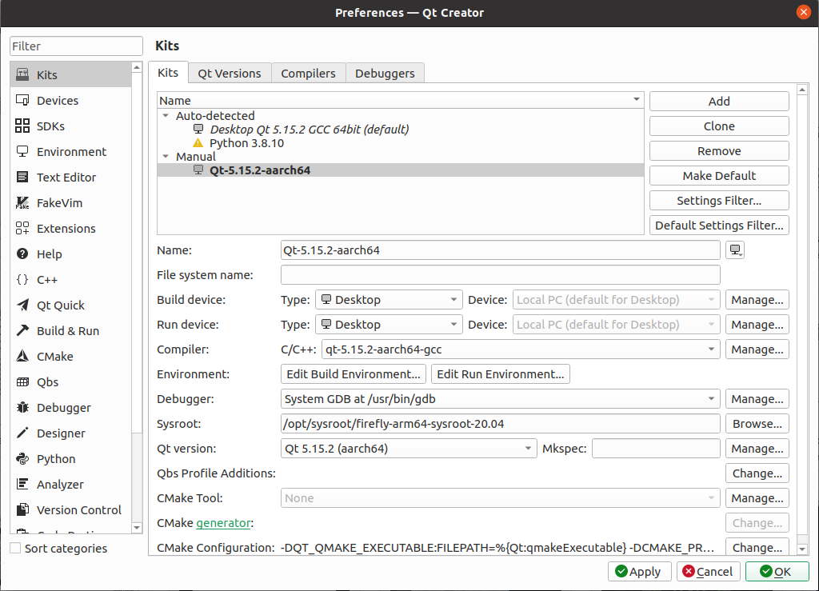

- Build and Run
Open the Gemba3D_Demo program and select the desired Kits.
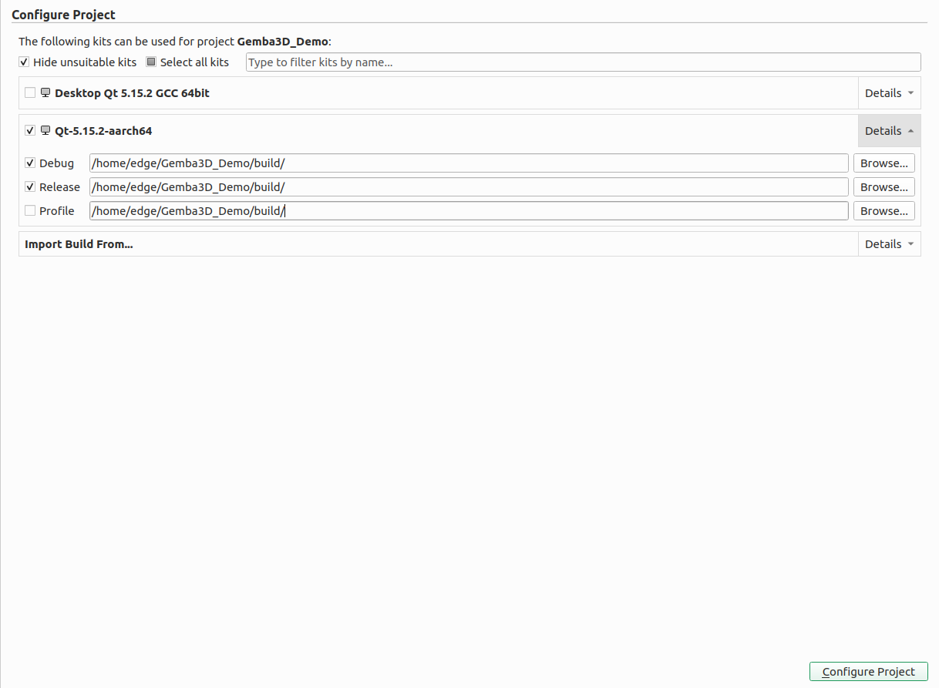

Note: You must extract the required OpenCV (arm64) and XVSDK (arm64) libraries for the 3D camera. Place them in the paths specified in the configuration files.

